

Data Visualization Trainee Early Internship - Sub-Group 27

Week-2 Final Report

Report Title: “Week-2: Exploratory Data Analysis and Dashboard Development on Outreach Campaign Data”

Associate Members:

Name | Email
Kolawole Oparinde | kolawole@vempower.org
Khusi Capoor | khusicapoor@vempower.org
Sudharma | sudharma@vempower.org
Shruti Mishra | shrutimishra@vempower.org

Team Members:

Name | Role | Email
Sumaiya Tasnim | Team Lead | sumaiyaa.tasnim.18@gmail.com
Wilgens Almonor | Project Scribe | Wilgensalmonor@gmail.com
Subashree J | Project Manager | subashreej03@gmail.com
Ayan Banik | Project Lead | ayanbanik001@gmail.com
Palak Garg | Team Member | palakgarg447@gmail.com

Introduction
In order to find useful insights, the Week 2 Data Visualization Trainee Early Internship phase concentrates on investigating, evaluating, and displaying outreach and application datasets. The goal is to use interactive dashboard design and exploratory data analysis to turn structured datasets into relevant tales, building on the cleaned and validated data from Week 1. This deliverable shows the capacity to convert data into strategic insights that direct well-informed decision-making and performance improvement by looking at trends, correlations, and performance indicators across campaigns, categories, and geographical areas.

Objectives
- To conduct Exploratory Data Analysis (EDA) on outreach and application datasets to identify key trends, patterns, and anomalies.
- To define and visualize Key Performance Indicators (KPIs) that effectively measure outreach performance.
- To design a dashboard prototype that highlights the most important metrics in an interactive and visually clear format.
- To derive actionable insights related to campaign timing, conversion behavior, and segmentation.
- To strengthen analytical storytelling skills through visualization and interpretation of real-world data.

Assigned Datasets:
Assigned Dataset (Raw) Before | Cleaned Dataset After
OutreachData.csv | Cleaned_OutreachData.csv
CampaignData.csv | Cleaned_CampaignData.csv
ApplicantData | Cleaned_ApplicantData

Tools We Used:
Tools | Purpose
Microsoft Power BI | For creating dynamic dashboards and visualizing KPIs with interactive elements.
Python (Pandas, Matplotlib, Seaborn) | For detailed data analysis, trend detection, and validation prior to visualization.
Word / PDF | For documenting the EDA findings and compiling the final report submission.

Expected Outcome
- A structured EDA Insights Report summarizing 3–5 major findings with supporting visual evidence.
- A dashboard prototype visualizing high-level KPIs such as outreach volume, response rate, and conversion rate.
- Identification of opportunities and performance gaps across categories, time periods, and regions.
- A clear narrative that links analytical findings to strategic outreach improvements.
- Enhanced proficiency in using analytical and visualization tools for real-world data interpretation.
Joining The Datasets
Schema Diagram:
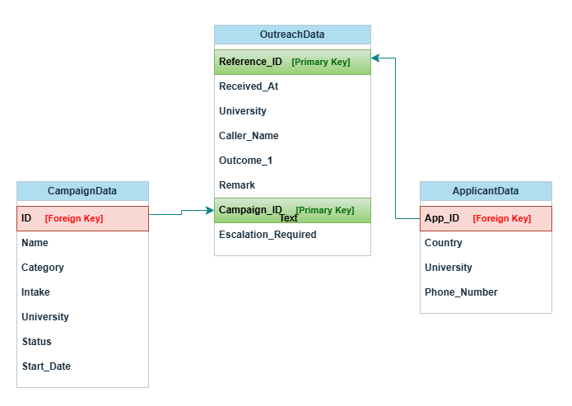

Column in Cleaned Dataset [primary keys] | Original Dataset | Matched With (Column & Dataset )  [Foreign keys]
Reference_ID | Cleaned_OutreachData.csv | App_ID (Cleaned_ApplicantData.csv)
Campaign_ID | Cleaned_OutreachData.csv | ID (Cleaned_CampaignData.csv)

Data Merging Methodology
The final dataset, Outreach_Campaign_Applicants_FinalData, was created by combining three cleaned datasets to provide a comprehensive view of outreach activities, campaign details, and applicant information.

Step 1: Merged Outreach and Campaign Data
The Campaign_ID column in Cleaned_OutreachData.csv was matched with the ID column in Cleaned_CampaignData.csv. This merge brought campaign-related information (such as Name, Category, Intake, University, Status, and Start_Date) into the outreach dataset.

Step 2: Again Merged Applicant Information
The Reference_ID column from the merged outreach-campaign dataset was matched with the App_ID column in Cleaned_ApplicantData.csv. This added applicant-level details, including Country, University, and Phone Number, to each outreach record.

Step 3: Verified Final Merged dataset
Total Records: 39717
Total Columns: 17
App_ID & ID columns matched so we kept valid columns Reference_ID,Campaign_ID. That’s why the columns are in total 17.
All Dataypes were fine.
No duplicate values found.
No missing values were found per columns, except Phone_Number column had 11 missing values.

Step 4: Handled Missing Values
11 missing phone numbers were filled with "Not Available" to ensure completeness.

Exported Dataset
The final merged dataset was exported as Outreach_Campaign_Applicants_FinalData.csv, ready for Exploratory Data Analysis and Dashboard creation in Power BI.

Dataset Structure:
Column Name | Data Type | Description of the Field
Reference_ID | int64 | Unique identifier for each outreach record.
Received_At | object | Date and time when the outreach was received.
University_x | object | University associated with the outreach (from Outreach dataset).
Caller_Name | object | Name of the person making the outreach.
Outcome_1 | object | Result of the outreach attempt (e.g., Connected, Not Connected).
Remark | object | Additional notes or comments regarding the outreach.
Campaign_ID | object | Identifier linking outreach to a specific campaign.
Escalation_Required | object | Indicates whether escalation was needed for the outreach.
Name | object | Campaign name (from Campaign dataset).
Category | object | Type or category of the campaign (e.g., Pre Admission, Post Admission).
Intake | object | Academic intake associated with the campaign.
University_y | object | University associated with the campaign (from Campaign dataset).
Status | object | Current status of the campaign (e.g., Completed).
Start_Date | object | Start date of the campaign.
Country | object | Applicant’s country (from Applicant dataset).
University | object | University of the applicant (from Applicant dataset).
Phone_Number | object | Applicant’s contact number

Exploratory Data Analysis (EDA)

The EDA seeks to find significant patterns and trends by methodically examining the cleaned and merged dataset, "Outreach_Campaign_Applicants_FinalData.csv." It looks at campaign types, timing patterns, applicant distribution by nation and university, outreach volumes, and response results. These insights offer a starting point for comprehending performance, determining which parts perform well and poorly, and guiding data-driven choices for enhancing upcoming outreach initiatives.
An overview of the Dataset:
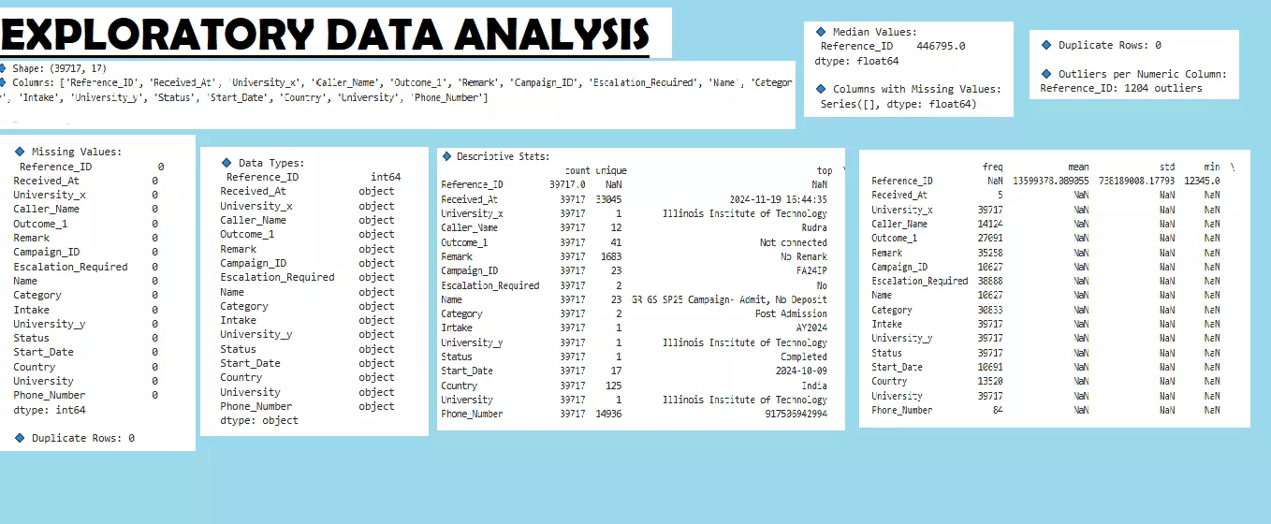
Descriptive Statistics including new Featured columns:

Metric | Count | Mean | Std Dev | Min | 25% | 50% | 75% | Max
Reference ID | 39,717 | 13,599,380 | 738,189,000 | 12,345 | 423,208 | 446,795 | 474,171 | 97,455,630,000
Hour | 39,717 | 14.49 | 2.72 | 9 | 12 | 14 | 17 | 22
Is_Response | 39,717 | 0.013 | 0.113 | 0 | 0 | 0 | 0 | 1
Is_Converted | 39,717 | 1.00 | 0.00 | 1 | 1 | 1 | 1 | 1

- Reference ID shows the unique identifier for each outreach.
- Hour represents the time of day the outreach occurred.
- Is_Response is binary (0 = no response, 1 = response).
- Is_Converted indicates conversion status, which is uniform in this dataset.
- Distribution of Outreach Hour

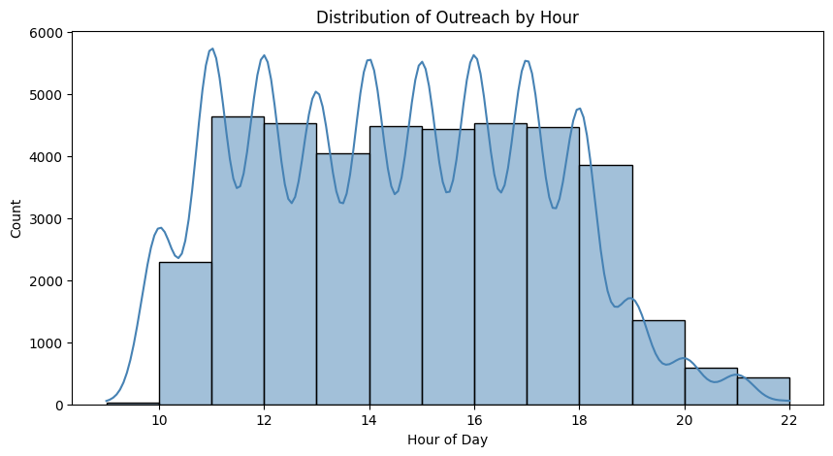

The “Distribution of Outreach by Hour” chart indicates hourly outreach activity, with low counts before 10 AM and after 7 PM, and persistent high activity between 11 AM and 7 PM. Around 11:30 AM, 1:30 PM, 3:30 PM, 5:30 PM, and 7 PM, peaks show up, indicating planned shifts or breaks. This knowledge aids in the optimization of personnel, resource distribution, and operational effectiveness. It also directs strategic scheduling to enhance the efficacy of outreach and permits precise forecasting and performance tracking.

- Weekly Outreach Pattern

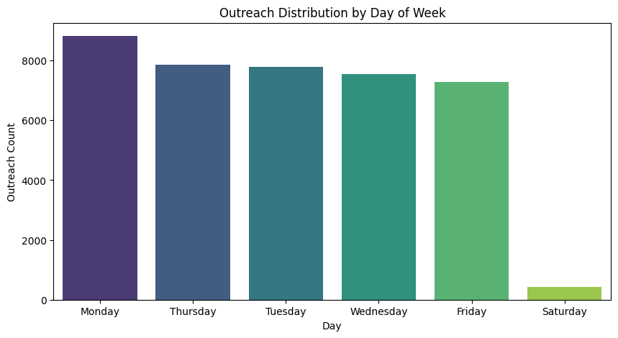

The “Outreach Distribution by Day of Week” chart shows that outreach activity is heavily concentrated on weekdays, with Monday having the highest volume (over 8,000) and Friday slightly lower. Saturday sees a steep drop-off, and Sunday data is missing or zero. This insight is crucial for workforce planning, operational scheduling, and campaign timing, ensuring peak staffing during high-volume weekdays while reserving weekends for maintenance or low-priority activities, and helping allocate resources efficiently.

- Response Rate Distribution

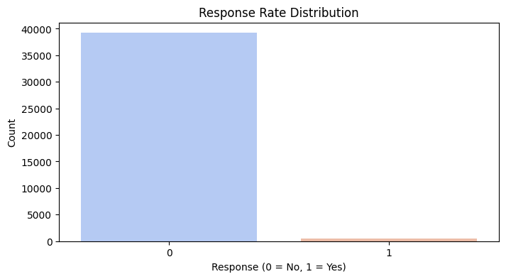
The “Response Rate Distribution” chart shows that the vast majority of outreach attempts result in no response, with “Yes” responses forming less than 2% of the total (~500 out of 40,000). This highlights a critical inefficiency in the outreach process, emphasizing the need to improve targeting, messaging, and timing.

- Correlation & Relationship Insights

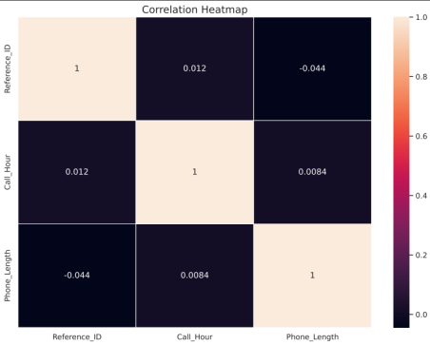

The Correlation Heatmap displays the linear relationships between Reference_ID, Call_Hour, and Phone_Length, showing all correlations are near zero (Reference_ID vs Call_Hour: 0.012; Reference_ID vs Phone_Length: −0.044; Call_Hour vs Phone_Length: 0.0084). This indicates no meaningful linear relationship between the variables, confirming that call duration and timing are independent of record sequence. The findings validate data integrity, guide modeling decisions (Call_Hour is not predictive of Phone_Length), and allow operational focus on each metric separately without concern for linear dependencies.

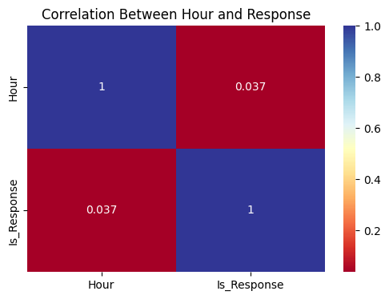
The correlation matrix reveals an extremely weak positive correlation between the hour of outreach and receiving a response. This indicates that the time of day has almost no impact on success, challenging assumptions about peak-hour effectiveness. .

Interpretation Summary:

Metric | Observation | Insight
Average Hour (14.5) | Most outreach happens in early afternoon | Indicates operational peak time
Response Rate (1.29%) | Very low overall | Suggests need to improve targeting or timing
Conversion Rate (1.0 constant) | Likely data anomaly | Requires validation
Weekday Distribution | Even or skewed outreach pattern | Can guide optimal outreach scheduling
Hourly Engagement Trend | High mid-day, low evening | Use to optimize call/response timing

(Important Insights)
- Outreach Campaign Performance Analysis

  - Outreach Volume & Timing Trends - by Month

Insight Goal: Discovers which hours yield highest engagement, optimizing call or message timing.

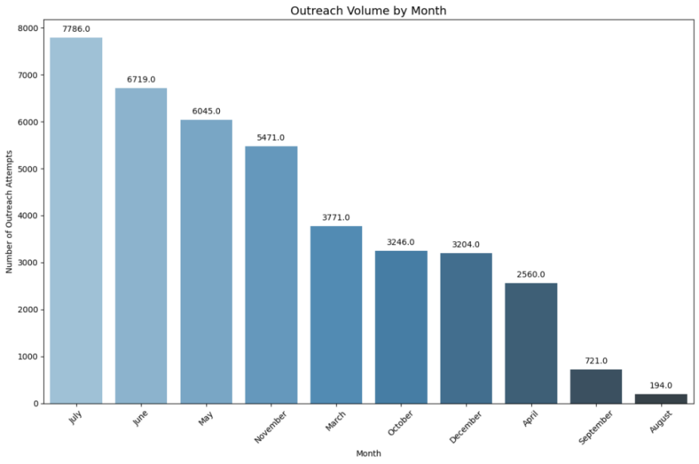
The "Outreach Volume by Month" chart shows the number of outreach attempts across the calendar year, highlighting that July (7,786), June (6,719), and May (6,045) are peak months, while August (194) and September (721) see the lowest activity. This seasonal pattern is important for planning campaigns, allocating staff and budget, and optimizing timing, as high-volume months may require more resources and low-volume months could indicate breaks or operational gaps. Understanding these trends helps prioritize outreach efforts, assess performance, and identify opportunities to improve efficiency during both peak and slow periods.

  - Outreach Volume & Timing Trends - by Day of Week

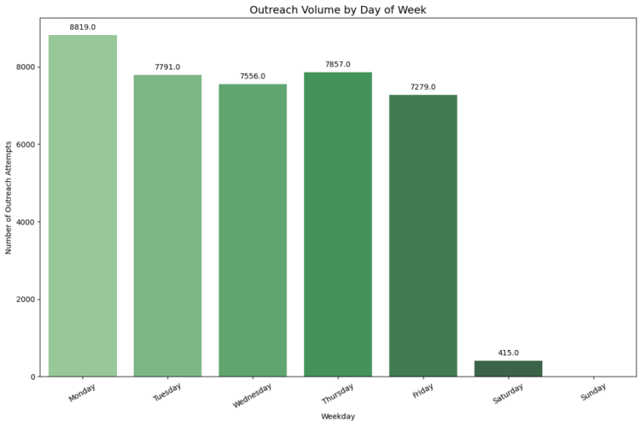
The "Outreach Volume by Day of Week" chart shows that outreach activity peaks on Monday (8,819 attempts) and remains consistently high through Friday (all above 7,200), while weekend activity drops sharply, with Saturday at 415 and Sunday at zero. This pattern highlights a standard Monday-to-Friday operational schedule, guiding staff allocation, workflow planning, and campaign timing. Understanding daily trends helps optimize contact efficiency, benchmark performance, and identify the best days to focus outreach efforts for maximum engagement.

2. Response Rate by Campaign Category

Insight Goal: Identifies which campaign categories generate higher engagement and which underperform.
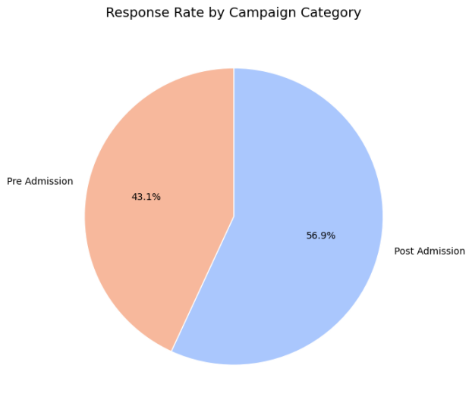
The "Response Rate by Campaign Category" pie chart shows that Post Admission campaigns generate the majority of responses (56.9%), while Pre Admission campaigns contribute 43.1%. This indicates that prospects in the post-admission phase are more engaged, making these campaigns highly effective. Understanding this distribution helps prioritize resources, optimize follow-ups, and identify opportunities to improve engagement in the Pre Admission phase, where even small gains could significantly boost overall response rates.

3.Effectiveness of First, Second, and Third Contact Attempts

Insight Goal: Determines if 1st, 2nd, or 3rd attempts are more effective, guiding future follow-up strategies.
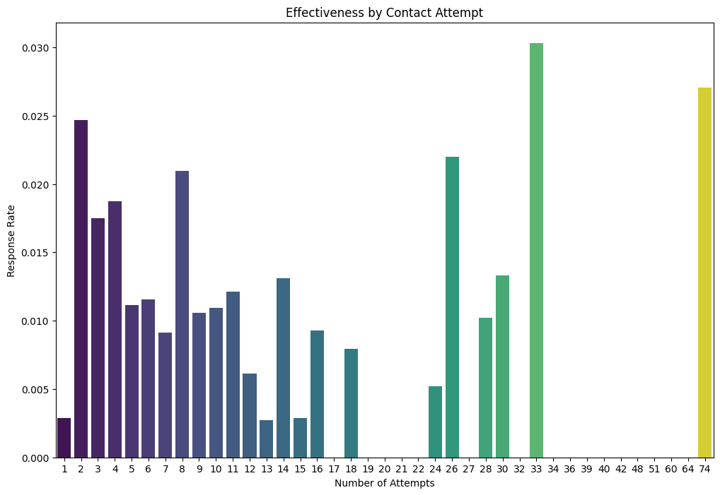
The "Effectiveness by Contact Attempt" chart shows that the first contact attempt has very low success (~0.3%), while the second attempt (~2.5%) and select later attempts (e.g., 32nd at 3.0%) are significantly more effective. This highlights the importance of immediate follow-up and strategic persistence, rather than relying solely on initial outreach. When compared to monthly outreach volume, it becomes clear that high activity alone does not guarantee results—success depends on targeting the most effective attempts. These insights help optimize contact strategies, allocate resources efficiently, and guide automated follow-up sequences for maximum engagement.

- Campaign Performance Overview

Insight Goal: Recognizes which campaigns deliver the best ROI, and which may require redesign.

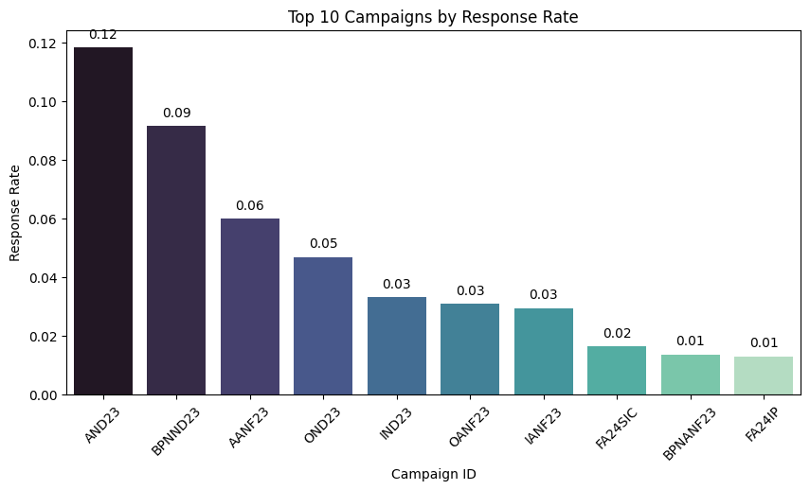
The “Top 10 Campaigns by Response Rate” chart highlights the effectiveness of the organization’s best-performing campaigns, with AND23 leading at 12% and BPNN D23 at 9%. A clear performance gap exists after the top two, while the lowest five campaigns achieve only 1–3%. Strategically, this chart guides replication of best practices, prioritization of resources toward high-performing campaigns, and realistic target-setting, showing that success depends on campaign execution rather than inherent limitations.

- Country/Region Performance (Segment-Level Insight)

Insight Goal: helps to understand which geographic segments or universities are more responsive to outreach.

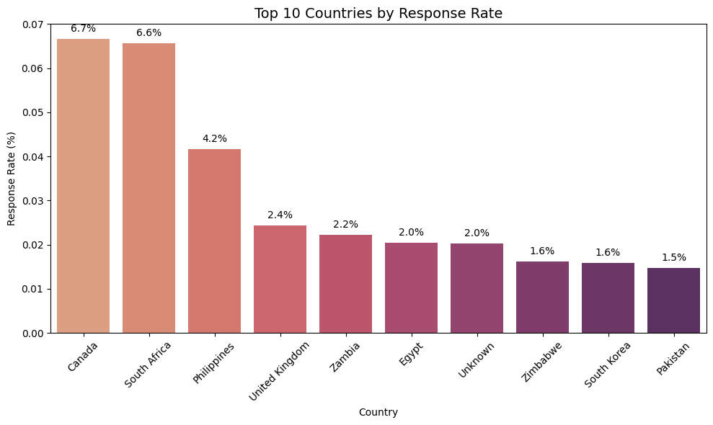

The “Top 10 Countries by Response Rate” chart shows a clear geographical disparity in outreach effectiveness. Canada (6.7%) and South Africa (6.6%) lead, while most other countries, including Pakistan (1.5%), lag significantly. This insight guides prioritization of high-performing regions, informs localization strategies, improves resource allocation, and highlights the need to address data quality issues such as the “Unknown” country segment.

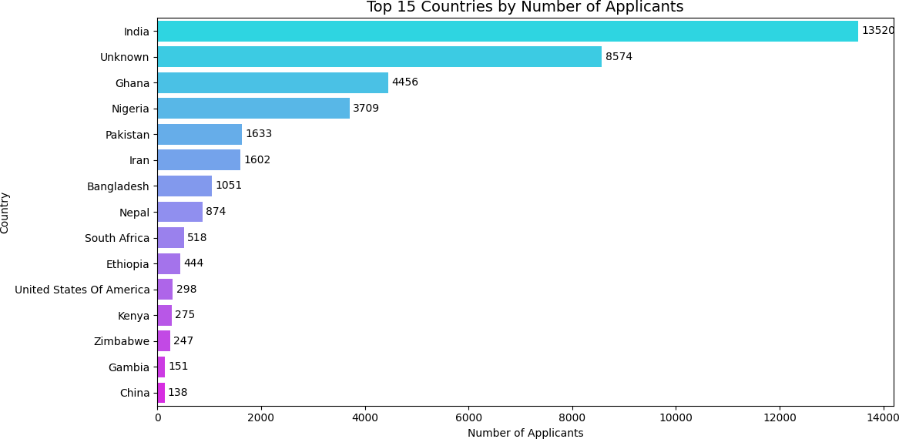
The bar chart "Top 15 Countries by Number of Applicants" highlights the leading applicant sources. India dominates with 13,520 applicants, followed by a large “Unknown” group (8,574), indicating missing data. Other key contributors include Ghana, Nigeria, and Pakistan, while China ranks lowest among the top 15. The results show a strong concentration from South Asia and Africa, emphasizing regional engagement. The high “Unknown” count signals a need for data quality improvement. Overall, these insights support targeted outreach, recruitment focus, and better data management.

- Timing-Based Performance Shifts

Insight Goal: Discovers which hours yield highest engagement, optimizing call or message timing.

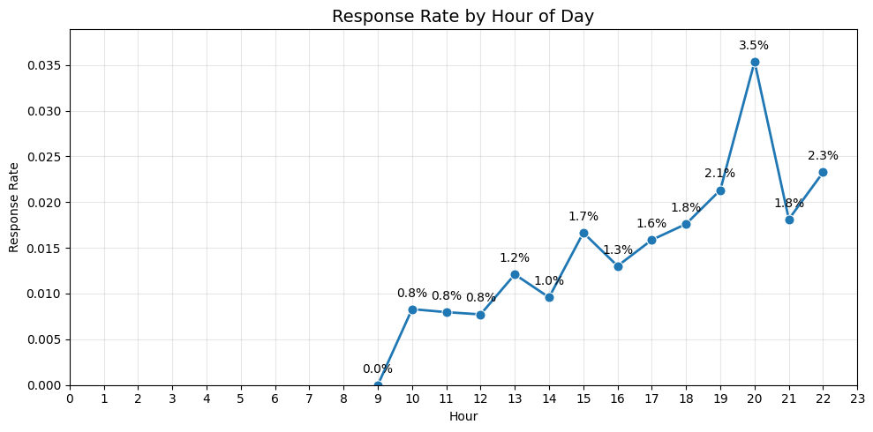

The “Response Rate by Hour of Day” chart reveals that outreach effectiveness peaks at 8 PM (3.5%), despite lower overall volume during that hour. Early hours (before 10 AM) show negligible responses, while mid-day response rates remain modest (0.8–1.8%). This insight highlights the importance of scheduling critical outreach later in the evening to maximize engagement, optimize ROI, and better align with audience availability, rather than merely focusing on high-volume hours.

7. Conversion Analysis (if Status indicates success)

Insight Goal: Can be seen which outreach categories directly lead to successful conversions.

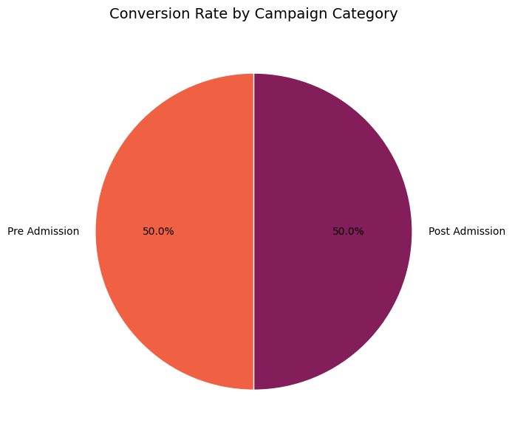

The “Conversion Rate by Campaign Category” pie chart shows an equal split in conversions between Pre Admission and Post Admission campaigns, each contributing 50% of total conversions. This balance highlights the importance of allocating resources evenly across both phases, ensuring that early-stage outreach and post-admission efforts are equally prioritized to maximize overall conversion and prevent applicant drop-off.

8. Phone Number / Contact Analysis

Insights: Shows proportion of contacts missing phone numbers. Highlights whether missing numbers impact response rates.
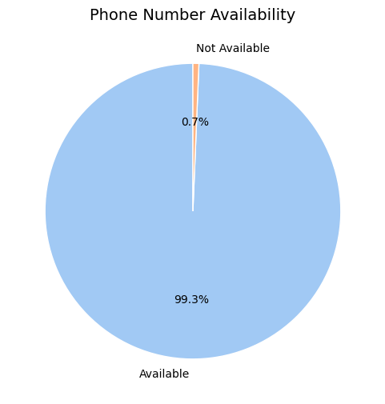
The “Phone Number Availability” pie chart shows that 99.3% of records have a phone number available, with only 0.7% missing. This near-complete coverage confirms high data quality, enabling reliable phone-based outreach and ensuring that analyses of response or conversion rates via phone are accurate. Minimal effort is needed for further data cleaning, allowing focus on other less-complete contact channels.

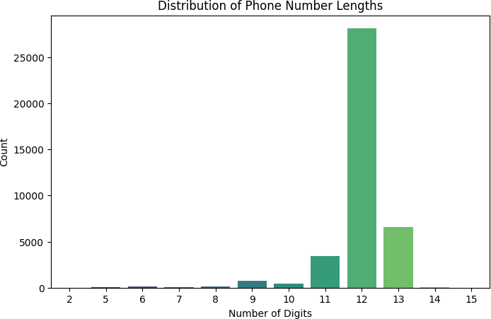

The histogram displays the distribution of phone number lengths within the database, showing a dominant 12-digit format with over 27,000 entries, followed by 13 digits (~6,500) and 11 digits (~3,500). Very short or long numbers are rare, suggesting strong data consistency. The dominance of 12 and 13 digits implies that most phone numbers are stored in international format (including country codes). This pattern defines the organization’s standard structure for contact data, aiding in data validation, telephony configuration, and error detection for future data imports.

9. Outlier Detection – Phone Number Lengths

Insights: Identifies whether phone numbers with irregular lengths deviate from the standard 12-digit format, helping detect data entry errors and maintain consistency in contact records.
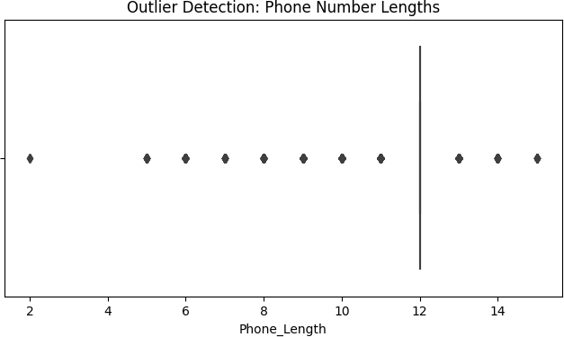
The box plot identifies outliers in phone number lengths, highlighting deviations from the standard format. Most entries cluster tightly around 12 digits, confirming it as the dominant and expected phone number length. All other lengths (e.g., 2, 5–11, 13–15 digits) are flagged as statistical outliers. While some variations like 11 or 13 digits may represent valid international formats, shorter or irregular lengths likely indicate incomplete or erroneous entries. This chart is essential for data cleaning and validation, ensuring that only structurally consistent phone numbers remain in the dataset, thereby maintaining high data integrity for outreach operations.

10. Segmentation by Intake / University Tier

Insights: Shows which tier of universities is more responsive, useful for prioritization.

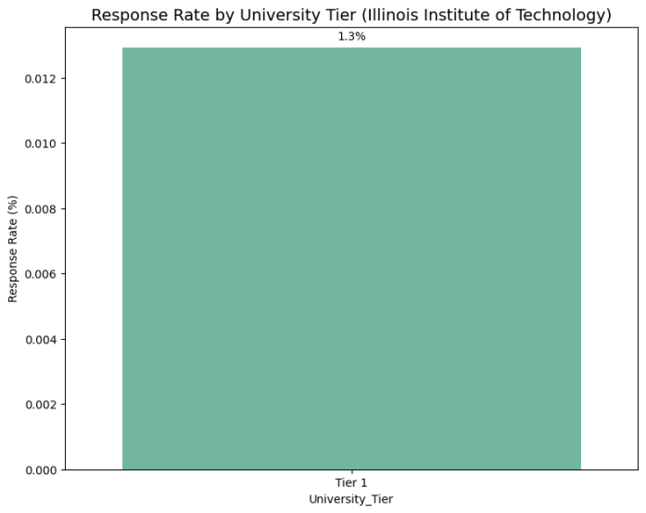
The chart “Response Rate by University Tier (Illinois Institute of Technology)” shows that outreach to the Tier 1 university category, specifically the Illinois Institute of Technology, achieved a 1.3% response rate. This is the only university record available in the dataset, so no comparisons with other universities or tiers can be made. Despite the lack of comparative data, this serves as a baseline for measuring future outreach efforts to this segment and calculating ROI. It also highlights the need for additional data to assess performance across other university tiers and guide resource allocation.

11. Campaign Category vs Attempt Effectiveness

Insights: Identifies which categories benefit from additional contact attempts. Helps plan follow-up strategy per campaign type.
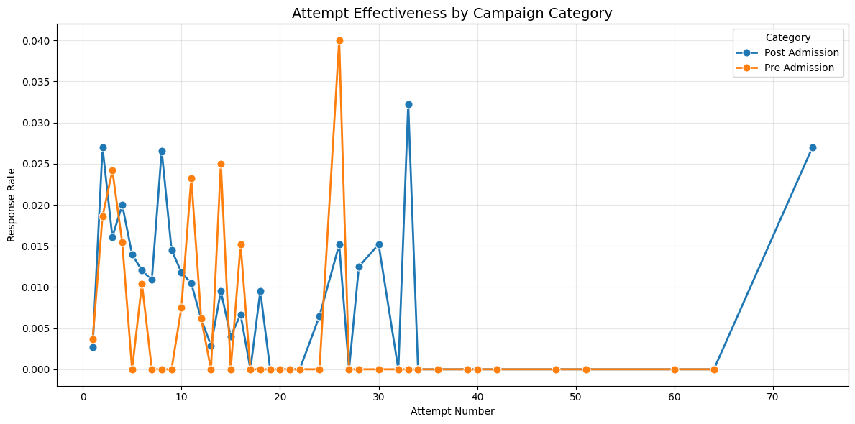

The “Attempt Effectiveness by Campaign Category” chart compares response rates across sequential outreach attempts for Pre Admission (orange) and Post Admission (blue) campaigns. Both categories show high effectiveness in the first 15 attempts, but Pre Admission peaks early (around Attempt 25–28 at 4%) and drops to 0% after Attempt 35, whereas Post Admission maintains measurable responses up to Attempt 75, peaking late at 2.7%. The chart highlights diminishing returns, volatility, and the need for a dual strategy: limit attempts for Pre Admission campaigns while persisting with Post Admission efforts to maximize conversions and optimize resource allocation.

- Distribution of Application IDs

Insights: Confirms sequential assignment of IDs and overall data volume. Helps validate data integrity and detect anomalies.

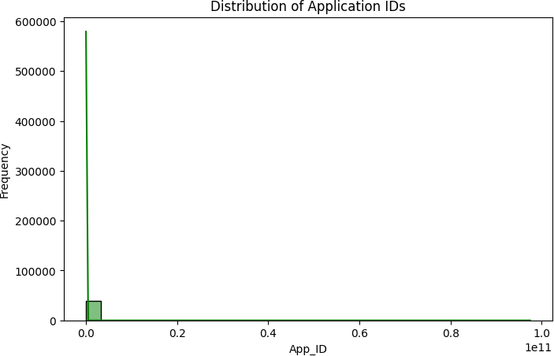

The histogram illustrates the frequency distribution of Application IDs, showing a highly left-skewed pattern where nearly all IDs are concentrated near the lower range. The first bin (IDs under 101010^{10}1010) peaks around 600,000 records, confirming the sequential and incremental nature of ID assignment. The absence of high-value outliers indicates consistent data generation without system anomalies, validating the integrity and structure of the application database.

- Top Callers (by number of calls) - Top 15
Insights: Reveals top-performing callers and workload concentration. Guides resource allocation, training, and risk management.
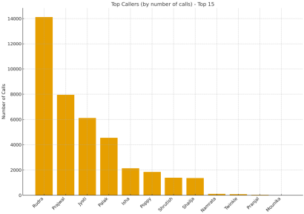
The Top Callers (by number of calls) – Top 15 chart shows a highly skewed distribution of call volumes among the top performers. Rudra leads with ~14,100 calls, nearly double the second-ranked Prajwal (~7,900), while the remaining top 15 show a rapid drop-off, with the lowest five under 200 calls. This highlights uneven workload distribution and a concentration of productivity among a few individuals. The implications include business continuity risk due to reliance on top performers, performance benchmarking for setting team goals, training opportunities to uplift lower-volume callers, and the need for resource management to prevent burnout among the top contributors.

(Advanced Insights using Excel)
- Trend of Categories vs. Phone Numbers

Insights: Tracks peaks and gaps in category and phone number activity over time. Supports planning for high-volume periods and resource allocation.
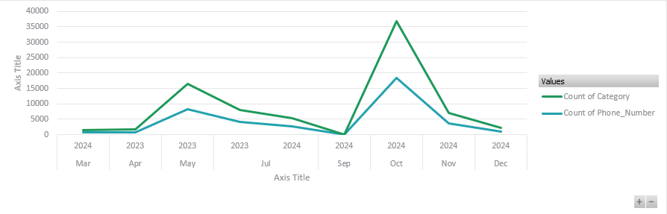
The line chart tracks Count of Category (green) and Count of Phone_Number (blue) over time. Category counts are consistently about double the phone number counts. Two major spikes are observed: May 2023 (≈17k categories, 9k phone numbers) and October 2024 (≈37k categories, 19k phone numbers).The chart highlights extreme volatility and recurring peak events, indicating seasonal or event-driven activity. The non-sequential years (2024, 2023, 2024) suggest timeline inconsistencies.
Implications: Peaks require capacity planning and resource allocation, investigation into spike causes, and verification of data integrity. The stable ratio between categories and phone numbers is useful for process monitoring and forecasting.

- Outreach Attempts Over Time

Insights: Highlights periods of high and low outreach activity. Assists in optimizing timing, staffing, and follow-up strategies.
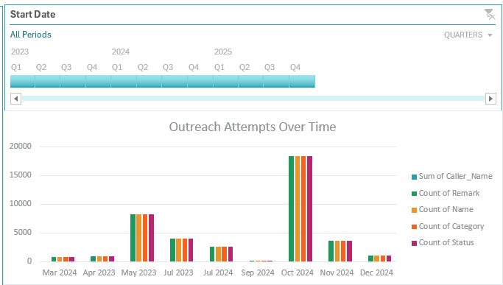

The grouped column chart "Outreach Attempts Over Time" tracks five closely aligned metrics (Caller_Name, Remark, Name, Category, Status) across select months from 2023–2024, all effectively measuring the same outreach events. The chart shows extreme variation, with low baseline months (<1,500 attempts), moderate peaks (~4,000 in Jul 2023/Nov 2024), and major spikes in May 2023 (~8,000) and October 2024 (~18,000). The perfect alignment of metrics confirms data consistency, while the spikes highlight critical periods for staffing, campaign analysis, and resource planning. Low-volume months suggest potential operational lulls or seasonality, and metric redundancy indicates a simpler single-count approach could suffice for reporting.

EDA Summary

The dataset comprises a total of 39,717 applicants originating from 125 countries, representing a diverse global applicant pool. However, only one university is recorded in the dataset, indicating that the outreach efforts are institution-specific. Among all countries, India emerges as the most dominant source of applicants, contributing the highest volume to the dataset.

Important Note: During EDA, new featured columns—Month, Weekday, Hour, Is_Response, Is_Converted, Phone_Status, University_Tier—were created to enhance analysis and support dashboard development. The resulting dataset was exported as “Cleaned_Outreach_Campaign_Applicants_FinalData.csv”.

- To see how these charts were created using Python in Jupyter Notebook, visit this link:
https://github.com/sumaiya-tasnim-18/Data-Visualization-Trainee-Intern
Check there (Folder:Week-2 → “EDA_of_joined_Dataset.ipynb”. Also there is available → the joined dataset & dashboard → .pbix file of Power BI)

Planning of Dashboard Creation in Power BI

The planning phase for the Outreach Campaign Performance Dashboard focused on defining key business objectives, identifying critical metrics, and selecting the appropriate visualizations and filters to enable actionable insights for operational and strategic decision-making.

At first, We started with DAX formulas creation, that which are needful for our dashboard creation.

DAX Formulas were created:

Column Created | DAX Formula
Total Outreach Attempts | Total Outreach Attempts = COUNTROWS('Cleaned_Outreach_Campaign_Applicants_FinalData')
Response Rate (%) | Response Rate (%) = DIVIDE(CALCULATE(COUNTROWS(FILTER('Cleaned_Outreach_Campaign_Applicants_FinalData', 'Cleaned_Outreach_Campaign_Applicants_FinalData'[Is_Response] = 1))), COUNTROWS('Cleaned_Outreach_Campaign_Applicants_FinalData'), 0) * 100
Conversion Rate (%) | Conversion Rate (%) = DIVIDE(CALCULATE(COUNTROWS(FILTER('Cleaned_Outreach_Campaign_Applicants_FinalData', 'Cleaned_Outreach_Campaign_Applicants_FinalData'[Is_Converted] = 1))), COUNTROWS(FILTER('Cleaned_Outreach_Campaign_Applicants_FinalData', 'Cleaned_Outreach_Campaign_Applicants_FinalData'[Is_Response] = 1)), 0) * 100
Average Attempts per Response | Average Attempts per Response = DIVIDE([Total Outreach Attempts], CALCULATE(COUNTROWS(FILTER('Cleaned_Outreach_Campaign_Applicants_FinalData', 'Cleaned_Outreach_Campaign_Applicants_FinalData'[Is_Response] = 1))), 0)
Escalation Rate (%) | Escalation Rate (%) = DIVIDE(CALCULATE(COUNTROWS(FILTER('Cleaned_Outreach_Campaign_Applicants_FinalData', 'Cleaned_Outreach_Campaign_Applicants_FinalData'[Escalation_Required] = "Yes"))), [Total Outreach Attempts], 0) * 100

Final Dashboard of Outreach Campaign Performance Tracker:

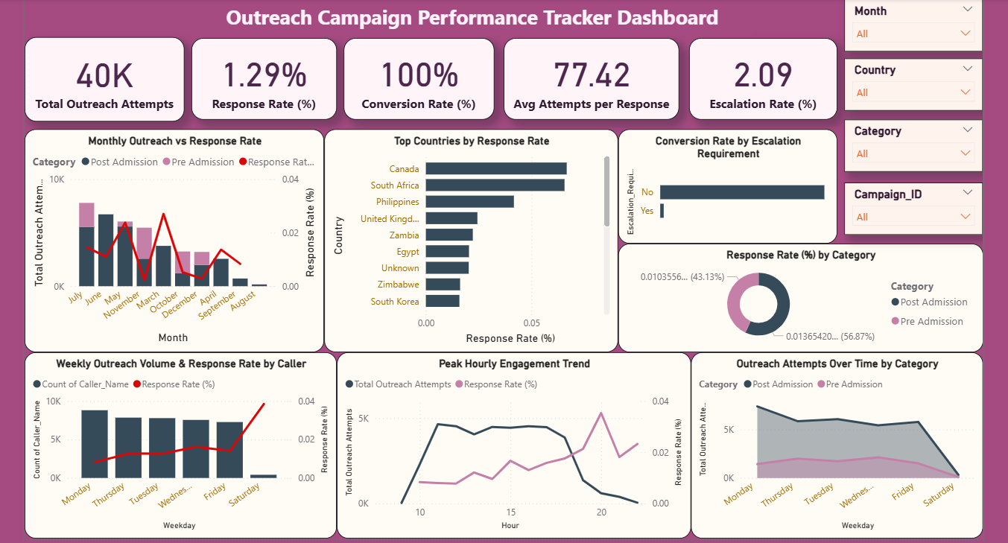

Dashboard KPIs Summary:

KPI Title | Why It’s Important
Total Outreach Attempts | Measures total effort and scale of outreach campaigns; helps monitor operational load.
Response Rate (%) | Evaluates effectiveness of outreach; indicates quality of targeting and messaging.
Conversion Rate (%) | Measures campaign success in achieving final objectives; validates end-to-end process efficiency.
Average Attempts per Response | Highlights efficiency of contact process; identifies potential operational waste.
Escalation Rate (%) | Indicates complexity of cases; helps plan management support and assess process bottlenecks.

Dashboard Visualization Summary:

Visualization Title | Chart Type | Columns Used | Why It’s Important
Monthly Outreach vs. Response Rate | Line & Stacked Column Chart | Month, Total Outreach Attempts, Response Rate | Identifies high/low activity months and helps plan staffing/resources.
Top Countries by Response Rate | Clustered Bar Chart | Country, Response Rate | Guides geographic targeting and resource allocation for maximum ROI.
Response Rate (%) by Category | Donut Chart | Category, Response Rate | Helps prioritize campaign types based on effectiveness.
Weekly Outreach Volume & Response Rate by Caller | Line & Clustered Column Chart | Week, Caller/Agent, Total Outreach Attempts, Response Rate | Measures individual staff performance and weekly efficiency.
Conversion Rate by Escalation Requirement | Clustered Column Chart | Escalation_Required, Is_Converted | Confirms process efficiency; escalations do not hinder conversions.
Peak Hourly Engagement Trend | Line Chart | Hour, Response Rate | Optimizes outreach timing and staff scheduling for maximum engagement.
Outreach Attempts over Time by Category | Area Chart | Weekday, Category, Total Outreach Attempts | Helps identify which campaigns dominate over time and optimize follow-up strategy.

Dashboard Filters Summary:

Filter Title | Why It’s Important
Month | Enables temporal analysis to identify peak periods, seasonality, and plan resource allocation.
Country | Supports geographic targeting, market efficiency, and segmentation of outreach strategy.
Campaign Category | Helps compare effectiveness of different campaign types and optimize messaging per stage.
Campaign ID | Allows drilling into individual campaigns for benchmarking and actionable insights.
Conclusion:
In Week 2, we represented a smooth transition from data preparation to insight generation. Meaningful trends in the outreach campaign dataset were discovered through comprehensive exploratory data analysis and the building of KPI-driven dashboards. The visualizations effectively emphasized performance trends across categories, time periods, and geographies, allowing for a better understanding of engagement efficiency and conversion behavior. This level not only improved analytical and visualisation skills, but also highlighted the need of transforming data into actionable insights. The built dashboard serves as a solid foundation for data-driven decision-making, resulting in improved outreach initiatives and operational effectiveness. It sets the foundation for Week 3, in which strategic advice and presentation design will improve the data's storytelling.

Next Steps for Week-3:

- We’ll review key insights and trends from Week-2’s EDA and dashboard analysis.
- We’ll create 3–4 actionable, data-driven recommendations for outreach and enrollment goals.
- We’ll design a 6–8 slide deck with clear visuals, concise text, and a “Next Steps” section.
- We’ll finalize the presentation professionally and prepare to deliver a confident, data-backed briefing.

